

**Air pollution detection using Arduino**

**Section: I**

**Group: 03**

**Submitted by**

|  |  |  |  |
| --- | --- | --- | --- |
| **Name** | **Id** | **Mail** | **Cell** |
| Hossain, Shahriar | 17-34702-2 | shahriarhossainaiub@gmail.com | 01521420185 |
| Himi, Humayra | 17-34572-2 | himihumayra97@gmail.com | 01624681821 |
| Zannat, Tajkurun | 17-34345-1 | mumuzannat07@gmai.com | 01795758044 |
| Islam,Md.Anik | 17-33459-1 | islamanik6366@gmail.com | 01303159123 |
| Shahid, Imran Ush | 18-37307-1 | imranshabi67@gmail.com | 01646316872 |
| Hridoy,Abdullah Al Ahsan | 17-35682-3 | abdullahahasan890@gmail.com | 01533532176 |
| Md. Asadujaman | 16-32537-2 | asadujaman@gmail.com | 01762873057 |
| Hasan, Morad | 17-35566-3 | moradhasan370073@gmail.com | 01884006326 |
| Kabir, Daiyan | 18-37507-1 | kabirdaiyan@gmail.com | 01754062482 |

**Submitted to**

**Sujan Howlader**

**Assistant Professor,**

**American International University-Bangladesh**



**Air pollution detection using Arduino**

Hossain, Shahriar

17-34702-2

Section: I

Department of Computer Science and Engineering

American International University-Bangladesh

[shahriarhossainaiub@gmail.com](mailto:shahriarhossainaiub@gmail.com)

Shahid, Imran Ush

18-37307-1

Section: I

Department of Computer Science and Engineering

American International University-Bangladesh

[imranshabi67@gmail.com](mailto:imranshabi67@gmail.com)

Kabir, Daiyan

18-37507-1

Section: I

Department of Computer Science and Engineering

American International University-Bangladesh

[kabirdaiyan@gmail.com](mailto:kabirdaiyan@gmail.com)

Himi, Humayra

17-34572-2

Section: I

Department of Computer Science and Engineering

American International University-Bangladesh

[Himihumayra97@gmail.com](mailto:Himihumayra97@gmail.com)

Hridoy, Abdullah Al Ahsan

17-35682-3

Section: I

Department of Computer Science and Engineering

American International University-Bangladesh

[abdullahahasan890@gmail.com](mailto:abdullahahasan890@gmail.com)

Zannat, Tajkurun

17-34345-1

Section: I

Department of Computer Science and Engineering

American International University-Bangladesh

[mumuzannat07@gmail.com](mailto:mumuzannat07@gmail.com)

Md. Asadujaman

16-32537-2

Section: I

Department of Computer Science and Engineering

American International University-Bangladesh

[asadujaman@gmail.com](mailto:asadujaman@gmail.com)

Islam, Md. Anik

17-33459-1

Section: I

Department of Computer Science and Engineering

American International University-Bangladesh

[Islamanik6366@gmail.com](mailto:Islamanik6366@gmail.com)

Hasan, Morad

17-35566-3

Section: I

Department of Computer Science and Engineering

American International University-Bangladesh

[moradhasan370073@gmail.com](mailto:moradhasan370073@gmail.com)

***Abstract – This project is to deal with the air pollution in Bangladesh. Air pollution is very common in Bangladesh. Now, the pollution is everywhere. The aim of this project is to make the environment pollution free especially the environment inside the house. Making this device is very easy using electronic devices. It will activate the alarm if it detects the over pollution rate.***

***Keyword – Air Pollution, environment, diseases, chidren.***

I. INTRODUCTION

Air pollution is one of the major reason of many diseases. In this current situation, air pollution is increasing but we cannot notice because we are used to with this pollution. So we want to work in this topic for detecting polluted air. By working on this topic we can detect polluted air and can reduce the pollution so that we can stay safe from air pollution and also we can keep our environment better.

The main goal of our project is to identify the level of air pollution. We want to implement a system that will check the level of purity of air particles and gas floating in the air. When the level of all these elements in the air increases, the light will blink and the buzzer will active. In this way the cause of pollution can be avoided by identifying the pollution.

In future, we can use this product everywhere such as office, car etc. though it is small in size.

II. LITERATURE REVIEW

In this research paper, sensors are used to monitor the air quality.MQ-9 and MQ-135 is used as gas sensor and GP2Y1010AU0F is used as dust sensor and by using this sensor it is possible to identify the plastics. All the sensors are connected to Arduino Mega. The device measures the pollutants in the air and generates real time data, which can either be seen on a computer or an Android device using the Bluetooth module [1].

This paper presents a wireless sensor network system for indoor air quality monitoring applications. A gas sensor and a microcontroller Arduino are used for developing the system. A commercial off-the-shelf ZigBee module is used for achieving mesh network and it simplifies the warless sensor network. A least-square estimation-based method is developed for calibration of micro gas sensors.

III. IMPACT ON SOCIETY

This project can create a great impact on society, mostly positive impact. Most of the children are suffering from different diseases which are mainly occurred by air pollution. May be we cannot ignore the outside pollution of house but we can fix it inside the house. If we can detect that there is pollution inside the house, then we can try to reduce the pollution which will help the children to keep safe from illness.

IV. IMPLEMENTATION

To implement this project, we will need some basic equipment-

* MQ135 Air Quality Sensor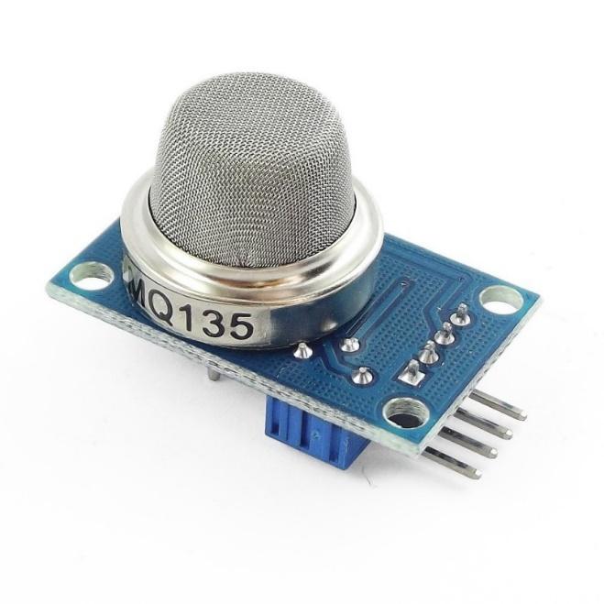
* Arduino UNO

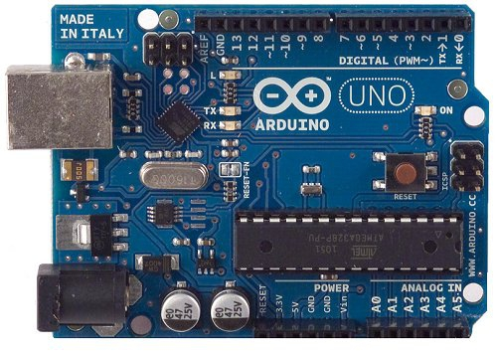

* 16 X 2 LCD

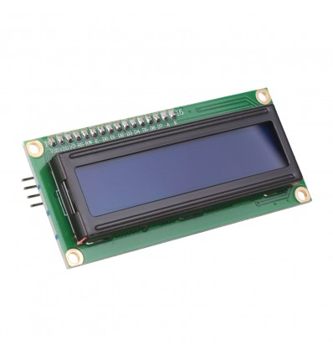

* Buzzer

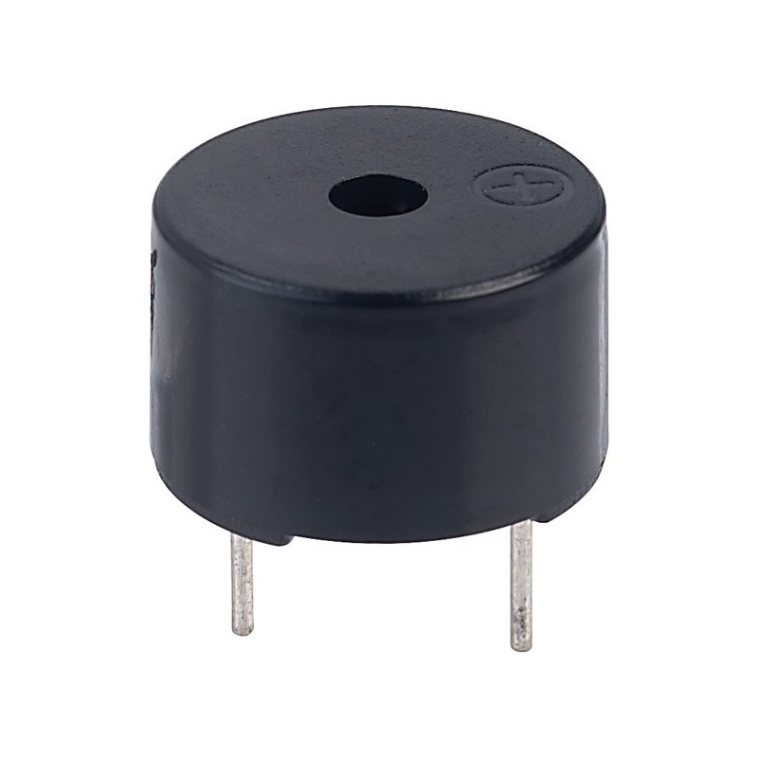

* LED

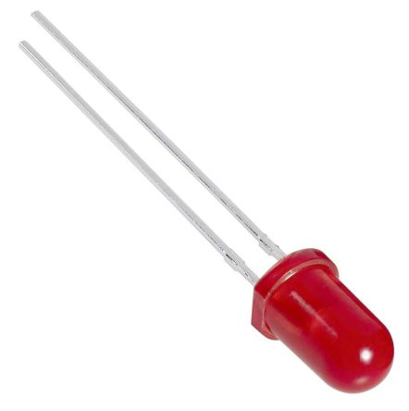

* Jumper Wires

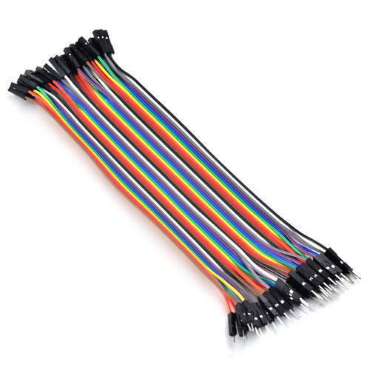

* Breadboard

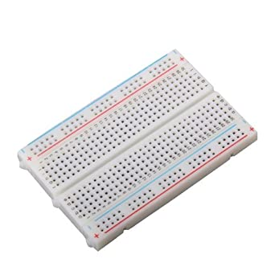

This equipment will setup according to the diagram which will be given later. Then we have to insert the code into the Arduino to run the project.

After building up the project it will look like-

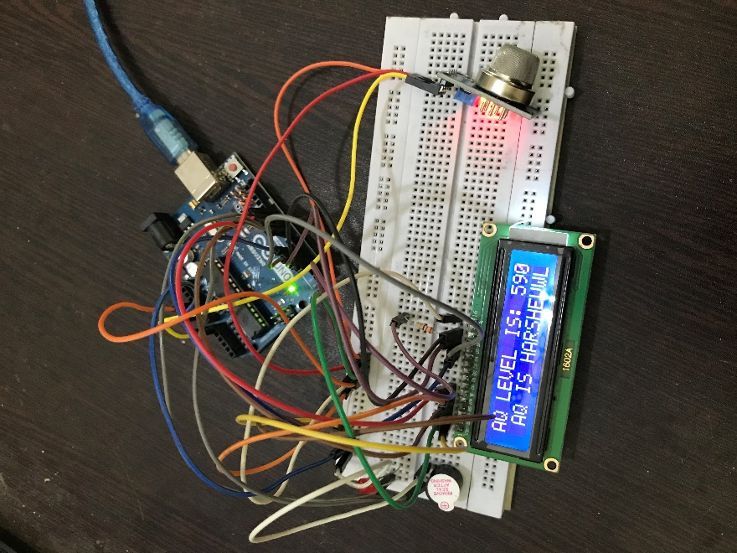

V. SIMULATION AND RESULT

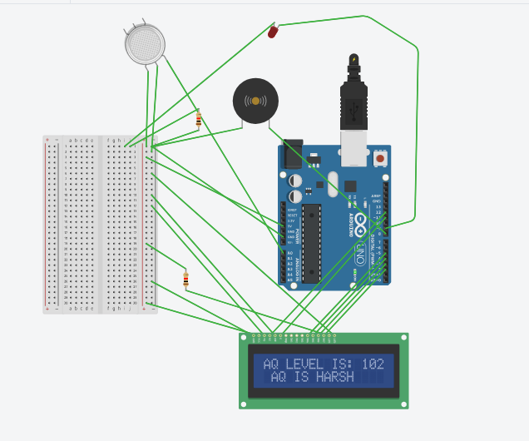

VI. BUDGET ESTIMATION

|  |  |  |
| --- | --- | --- |
| Item | Quantity | Price (Taka) |
| MQ135 Sensor | 1 | 194 |
| Arduino UNO | 1 | 399 |
| 16x2 LCD | 1 | 175 |
| Breadboard | 1 | 80 |
| Jumper Wires | 1 | 90 |
| LED | 1 | 5 |
| Buzzer | 1 | 15 |

Here, the total price is 958 Taka.

VII. CODES

#include <LiquidCrystal.h>

const int rs=12, en=11, d4=5, d5=4, d6=3, d7=2;

LiquidCrystal lcd(rs,en,d4,d5,d6,d7);

int buz = 8;

int led = 9;

const int aqsensor = A0;

int threshold = 250;

void setup() {

pinMode (buz,OUTPUT);

pinMode (led,OUTPUT);

pinMode (aqsensor,INPUT);

Serial.begin (9600);

lcd.clear();

lcd.begin (16,2);

}

void loop() {

int ppm = analogRead(aqsensor);

Serial.print("AQ LEVEL IS: ");

Serial.println(ppm);

lcd.setCursor(0,0);

lcd.print("AQ LEVEL IS: ");

lcd.print(ppm);

if (ppm > threshold)

{

lcd.setCursor(1,1);

lcd.print("AQ IS HARSH");

tone(led,1000,200);

digitalWrite(buz,HIGH);

}

else

{

digitalWrite(led,LOW);

digitalWrite(buz,LOW);

lcd.setCursor(1,1);

lcd.print ("AQ IS GOOD");

}

delay (500);

}

VIII. CONCLUSION

Now-a-days, there are many air pollution control systems in the market. But, they are very costly. Not every family can afford them. In contrast, our project is very cheap. To set up the entire system it will just cost 958 Taka. Which is in budget range for almost every family. If we can successfully deliver the product and its benefits to everyone, then it can be a revolutionary solution to avoid air pollution.

IX. REFERENCES

[1] A.M.Husain, T.H.Rini, M.I. Haque, M.R.Alam, Air Quality Monitoring: The Use of Arduino and Android, Journal of Modern Science and Technology, Vol. 4., No. 1., September 2016 Issue., Pp. 86 – 96.

[2] S. Abraham, X.Li, A Cost-Effective Wireless Sensor Network System for Indoor Air Quality Monitoring Applications, The 9th International Conference on Future Networks and Communications (FNC-2014).